CLOSING CHECKLIST

The following checklist is a guide to help ensure a successful closing.

EARNEST MONEY CONTRACT
___ Earnest money check is payable to Mint Title Company and attached.
___ All parties have signed, initialed any changes and completed all dates.
___ All names are shown completely and with correct spelling.
___ Legal description is complete and correct.
___ All contact information (addresses, phone numbers and emails) is complete for all parties.
___ All exhibits and addendums are attached, to include the Seller’s Disclosure.

The effective date of the Contract is the trigger date to begin the entire closing process.
It is important to all parties, therefore we require it be completed prior to delivery of the contract.

ITEMS TO DELIVER TO MINT TITLE COMPANY AS SOON AS POSSIBLE
___ Survey. As required by the contract. If we are using the seller’s existing survey, it must be furnished, along with the T 47 Affidavit immediately after the contract is executed so that we may review and approve it.
___ HOA Information. Provide contact information so that we may order the resale certificate as required by the contract.
___ Payoff Information. Deliver seller’s existing loan number, social security number, phone number and contact person so that Mint may request the payoff.
___ Marital Status. Seller’s marital status from the time of acquisition of the property to the closing. If single at the time of acquisition but currently married and if the property being sold is their homestead, spouse must join in on all closing documents from the Contract through the final Deed.

ITEMS TO DELIVER TO MINT TITLE COMPANY PRIOR TO CLOSING
___ Commission. The % is not stated on the contract, please advise.
___ Termite Report. If required by the lender, please deliver the original report and invoice to your Closer and let us know if it has been paid. This information must show on the closing statement.
___ Home Warranty. Notify your Closer of the options selected, the amount and the name of the company. An invoice and the application must be at the closing.
___ Hazard Insurance. Buyer needs to arrange for insurance coverage and have the agent contact the Closer and their lender with details of coverage for lender requirements.
___ Repairs. If the lender approves the repairs being paid at closing, deliver original invoice to your Closer. Most lenders will not allow an escrow for repairs nor allow a credit to the buyer for the repair allowance and will require that repairs must be handled prior to closing.
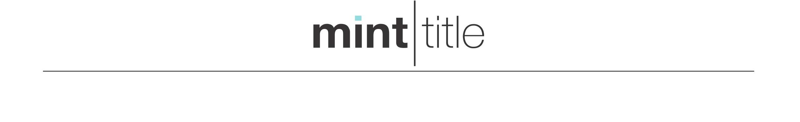
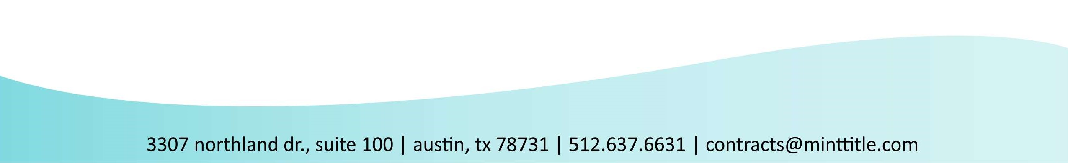
___ Good funds. We only accept wired funds transferred to Mint Title. The total amount due should be available prior to closing based on our receipt of the loan documents from the Lender. Please contact your Closer for wiring instructions.
___ Driver’s License, Passport, Military I.D. All parties signing closing documents must bring a valid, government issued identification.
___ Power of Attorney. If a power of attorney is to be used at closing, Mint Title Company and the lender must review and approve it prior to closing. Your Closer must be able to contact the principal of the power of attorney on the day of the closing.

